Monopoly Rules

* The game consists of two players, Dog and Car
* When a player passes over or lands on GO, the player receives £200.
* Each player receives £1500 at the beginning of the game. The game is considered to have an unlimited amount of money.
* Players do not go bankrupt – their balance can be negative.
* A game is played as a series of rounds. During a round, each player takes one turn. In each turn a number between 1 and 6 is generated (which represents the player throwing a six-sided dice). The player’s piece moves clockwise around the board by a number of squares equal to the number generated.
* Each square has a name. There are 6 special squares: GO, Penalty, Jail, Free Parking, Bonus and Go to Jail. There are 18 property squares. The property squares are grouped into 6 groups. The groups each have a different colour: brown, light green, red, blue, green, light blue, yellow and purple. There are two Airports.

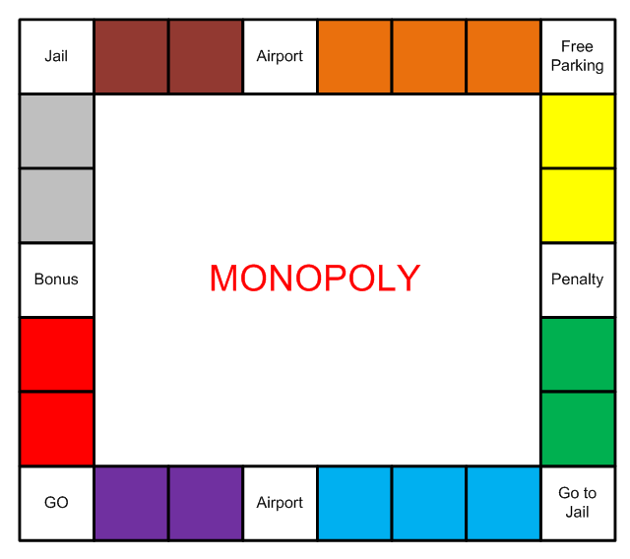An example of the board’s layout is shown below.

* The game is run as a simulation requiring no user input.
* The game is played for a maximum of 20 rounds
* For each turn, the name of the player and the generated number is displayed in the console. On the next line the name of the player and the name of the square that the player landed on are displayed. When a player lands on a property the following happens:
  + If the property is not owned, the player who landed on the property will buy it if they have a positive amount of money. If purchased, the price of the property is deducted from the player’s money and the player becomes its owner.
  + If the property is owned by the player that landed on it, nothing happens.
  + If the property is owned by another player, the player that landed on the property must pay its owner rent.
* When a player lands on an Airport the following happens:
  + If the Airport is not owned, the player who landed on the Airport will buy it if they have a positive amount of money. The cost is always £200. If purchased, the price of the Airport is deducted from the player’s money and the player becomes its owner.
  + If the Airport is owned by the player that landed on it, nothing happens.
  + If the Airport is owned by another player, the player that landed on the Airport must pay the owner a fee of £10.
    - Players always buy un-owned properties and Airports they land on if they have a positive amount of money.
    - The cost and the rent of the properties are given in the following table:

|  |  |  |  |
| --- | --- | --- | --- |
| **Property Name** | **Cost** | **Rent** | **Group** |
| Red Road | 60 | 5 | 0 (Red) |
| Red Street | 80 | 10 | 0 (Red) |
| Grey Road | 100 | 15 | 1 (Grey) |
| Grey Street | 120 | 15 | 1 (Grey) |
| Brown Road | 140 | 20 | 2 (Brown) |
| Brown Street | 160 | 20 | 2 (Brown) |
| Orange Road | 180 | 25 | 3 (Orange) |
| Orange Street | 180 | 25 | 3 (Orange) |
| Orange Way | 200 | 25 | 3 (Orange) |
| Yellow Road | 220 | 30 | 4 (Yellow) |
| Yellow Street | 240 | 30 | 4 (Yellow) |
| Green Road | 260 | 35 | 5 (Green) |
| Green Street | 280 | 35 | 5 (Green) |
| Blue Road | 300 | 45 | 6 (Blue) |
| Blue Street | 300 | 45 | 6 (Blue) |
| Blue Way | 320 | 45 | 6 (Blue) |
| Purple Road | 400 | 50 | 7 (Purple) |
| Purple Street | 420 | 50 | 7 (Purple) |

* The property rent is doubled if the same owner owns all of properties of a colour group.
* At the end of each player’s turn their balance is output to the console:

**Special Squares**

* If a player lands on “Go to Jail” then their piece immediately moves to the “Jail” square and £50 is automatically deducted.
* If a player lands on the 'Jail' square during a normal roll, the player is considered to be 'just visiting', and nothing special happens.
* The turn after a player has been moved to Jail is treated as a regular turn. The player has already paid to get out of jail.
* If a player lands on "Free Parking" then nothing happens.
* If a player lands on "GO" then they collect £200 as normal, but nothing else happens.
* If a player lands on “Penalty” then one of the 6 following random events occurs:
  + Pay food bill. Player loses £20.
  + Pay phone bill. Player loses £50.
  + Pay heating bill. Player loses £100.
  + Pay vehicle tax. Player loses £150.
  + Pay fuel bill. Player loses £200.
  + Pay windfall tax. Player loses £300.
* If a player lands on “Bonus” then one of the 6 following random events occurs:
  + Find some money. Player gains £20.
  + Win competition. Player gains £50.
  + Tax rebate. Player gains £100.
  + Win lottery. Player gains £150.
  + Bequest. Player gains £200.
  + Birthday. Player gains £300.

**Mortgaging**

* If a player’s funds go below zero then they must immediately mortgage one or more properties until their funds go above zero.
* If a player is unable to reach a value of zero by mortgaging properties, then they lose the game.
* The lowest value property is mortgaged first.
* When a property is mortgaged the player is paid the full value of the property.
* As soon as a player’s funds go above the cost of their lowest valued mortgaged property, they must repay the mortgage. Repaying the full value of the property.
* A mortgaged property does not collect any rent.